Hydrolysis of a Tosylate
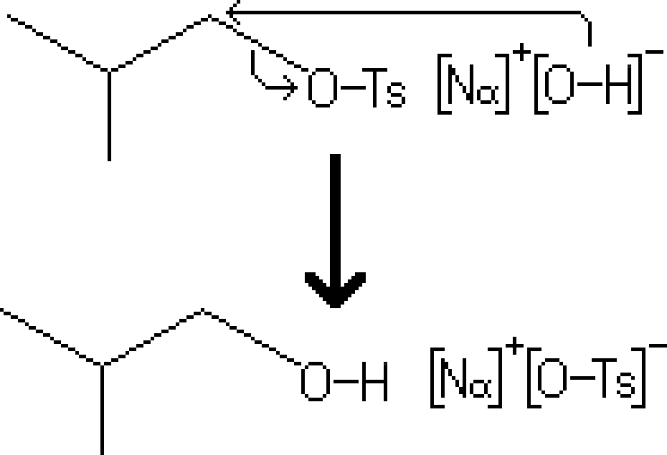
Reactants – Primary Alcohol, NaOH
Products – Primary Tosylate, NaOTs
Electron Movement
- SN2 Reaction – The electrons of the alcohol's oxygen, acting as the nucleophile, attach to the carbon with the tosylate group. In this situation, tosylate is a better leaving group, causing the displacement of the group.

Notes
- Since this reaction is based on the Sn2 mechanism, there are several conditions that may increase the rate of reaction
  - If in a solution, having the reactants in a polar aprotic solvent greatly increases rate of reaction.

